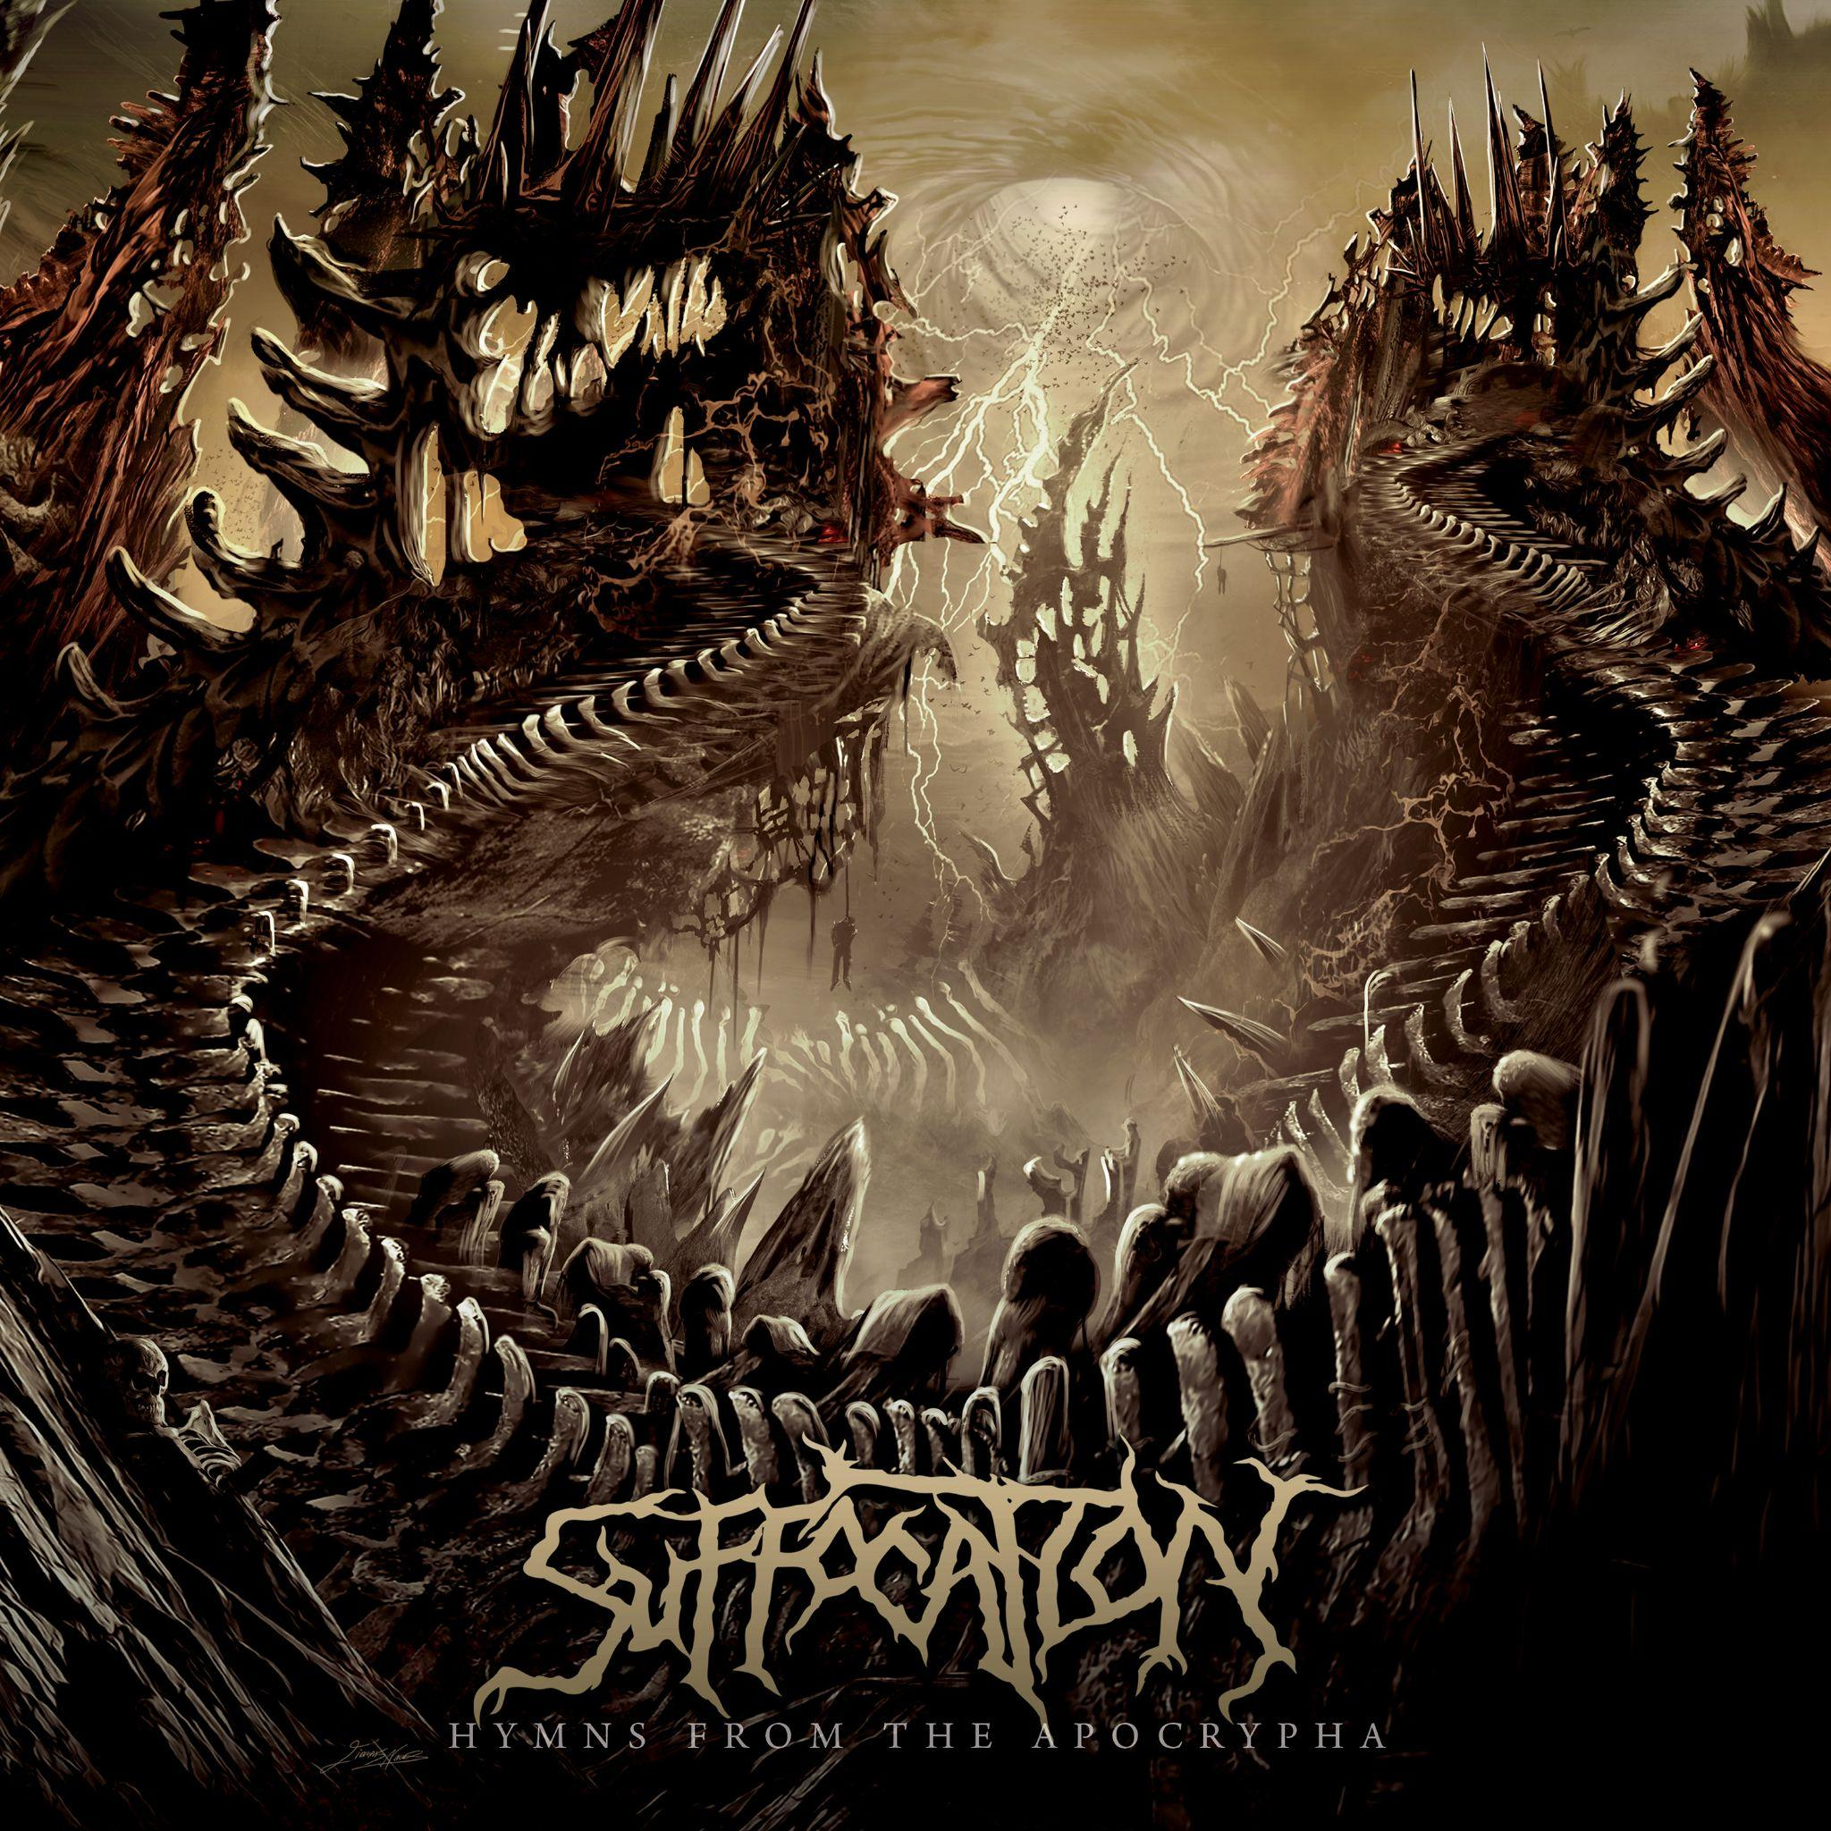
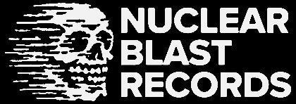

SUFFOCATION
Hymns From The Apocrypha

Release Date: November 3, 2023

Line up: | SUFFOCATION online:
Terrence Hobbs| Guitar  Derrek Boyer | Bass  Eric Morotti | Drums  Charlie Errigo | Guitar  Ricky Myers | Vocals | https://www.facebook.com/suffocation/  https://twitter.com/suffocationband  https://www.instagram.com/suffocationofficial/  https://www.youtube.com/user/suffocation
New York death metal legends SUFFOCATION unleash their ninth full-length album, Hymns from the Apocrypha, via Nuclear Blast. The follow-up to ...of the Dark Light (2017) pushes founder Terrance Hobbs (guitars), Derek Boyer (bass), Charles Errigo (guitars), Eric Morotti (drums), and newcomer Ricky Myers (vocals) to the very edges of extremity. Standout tracks ‘Seraphim Enslavement,‘ ‘Perpetual Deception,‘ and ‘Delusions of Mortality’ are emphatically SUFFOCATION but are enhanced with what Hobbs calls "progressive melodies." The crushing title track, ‘Immortal Execration,’ and the re-recording of ‘Ignorant Deprivation,’ featuring former throat-man Frank Mullen, are brutal alms to death metal's heaving masses.
“Hymns from the Apocrypha has a more natural/organic feel," says Boyer. "We recorded this album ourselves and intentionally took an old-school approach. This was the first time SUFFOCATION captured the essence of the band ourselves. Musically, our goal is to evolve as musicians and songwriters. Our intention has always been to create aggressive, well-composed, well-made, and well-produced music. We put a lot of time and thought into every aspect of our work. Whether performing live or producing ourselves in the studio, we push ourselves to perform to the best of our ability."
SUFFOCATION were founded in Long Island, New York, in 1988. Since then, they released foundational classics like Effigy of the Forgotten (1991), Breeding the Spawn (1993), and Pierced from Within (1995), with post-reformation slabs of savagery Souls to Deny (2004), Suffocation (2006), and Pinnacle of Bedlam (2013) proving death metal was not only SUFFOCATION's to own but that it also continued to be a viable art form, all three albums earning accolades at Metal Injection, Decibel, and Deaf Forever. To date, they've played over 2,000 shows, giving audiences from the United States and Germany to Australia and Brazil unforgettable blasts and trademark slams. Truly, the group's global influence is unmistakable and undeniable. Hymns from the Apocrypha isn't merely another album from the New Yorkers but a statement of intent. SUFFOCATION always have been and are here to slay.
"We will always be pushing for an extreme edge," Boyer says. "With each album, there is a new maturity. Whether it's a new vision of how we'll structure a song or if our approach to capturing our performances is going down a new path, no matter what, when we put something out, it will always be SUFFOCATION. Even if we're experimenting in production with our tones or how we approach our compositions, it will always be SUFFOCATION. After decades of this, we're not just going add a violin or feature a spoon man or some other bullsh*t. SUFFOCATION's raw, aggressive, fast, heavy, brutal death metal. Just as it has always been and will always be."
Without gigs, suffering from lockdowns, and having to cope with the physical distance between members—not everyone lives in Long Island—SUFFOCATION's creative principals conceived Live in North America (2021), featuring Mullen on his farewell tour, under the expert tutelage of Cryptopsy guitarist and burgeoning producer Christian Donaldson. After the pandemic, while SUFFOCATION toured their asses off in the US, Latin America, and Europe, the final pieces of Hymns from the Apocrypha emerged with utmost intensity. The first full song was ‘Seraphim Enslavement,’ with others like ‘Dim Veil of Obscurity,’ ‘Immortal Execration,’ and ‘Embrace the Suffering,’ arriving after tasking, if eventually productive writing sessions in Hobbs' lair.
"We have a little more progressive riffage in the new stuff," says Hobbs. "We still keep the older elements, though—if the machine isn't broken, don't fix it. I think the band's direction is great, and we feel we have grown in maturity, writing, and playing live. We're on a good path for the future while we bring a few new elements to the table for our fans and friends alike. That said, SUFFOCATION writes for SUFFOCATION."
Hymns from the Apocrypha's musical origins began in 2019 and lasted into the summer of 2023—’Descendants’ and ‘Immortal Execration’ were the last songs Hobbs and team penned. The album's lyrical bent—authored by inimitable frontman Myers—was fashioned throughout the songwriting process. The title track, ‘Hymns from the Apocrypha,’ tackles celestial envy and humanity's ruin. At the same time, ‘Perpetual Deception’ revisits the Son of Man (Jesus) and his continuous deceit, a nod to the classic SUFFOCATION track, ‘Jesus Wept.’ ‘Immortal Execration’ goes deeper into suicidal thoughts, cruelly bequeathed to humanity. Myers is a formidable vocalist—an absolute monster on ‘Seraphim Enslavement’ and ‘Delusions of Mortality’ — and the right man to formulate wicked lyrics.
"The lyrics are mainly about divine entities deceiving mankind with lies and delusions through ancient scriptures," Myers says, "Obscuring them from knowledge of their true origin; giving them hope that someday they will join their makers in eternal life. I tried to provide a different perspective on these merciless entities that created vessels enslaving humanity to suffer mentally and physically for their amusement."
SUFFOCATION took about a month and a half to record Hymns from the Apocrypha. They holed up at Hobbs and Boyer's InLine Studio in Long Island. The duo engineered and co-produced with Christian Donaldson (BENEATH THE MASSACRE, INGESTED), who was also re-enlisted to mix and master, with Dominic Grimard (CRYPTOPSY, SHADOW OF INTENT) assisting. If Breeding the Spawn was SUFFOCATION's production nadir, then Hymns from the Apocrypha is arguably the group's strongest-sounding, most sonically punishing album yet. From the growling bass and inhuman vocals on ‘Perpetual Deception’ to the merciless guitar crunch of Hobbs/Errigo and rapid-fire drumming on ‘Embrace the Suffering,’ SUFFOCATION have achieved death metal perfection.
"The entire process took about two months," says Boyer. "That's considering the tracks were sent out to be mixed and mastered in a different studio. It was mixed in about two weeks—I'm looking at all the time it took to get the files out of our system, sent over, time for Christian to get them into his system, and all the back and forth, requesting mix adjustments. Then, finally, when we were happy, he still had to run off the master in all formats and send it out to us and the label."
With stunning cover art by Greek illustrator Giannis Nakos (VOMITORY, THE CROWN), Hymns from the Apocrypha is characteristically SUFFOCATION. That is to say, it's uncompromisingly brutal, artistically gutsy, and aurally heavy. Clearly, SUFFOCATION, as they head into their 35th Anniversary, are at the peak of their potential. Death metal or die!
"Perseverance isn't easy," says Hobbs. "Playing aggressive music is in our blood. Being a live band with actual recordings that are back-to-the-roots of being a real band—not a digital representation of over-edited stuff in today's overwhelmed music industry—shows who we are. SUFFOCATION, as a live band, is key to us all. I would've never thought that this would be a 35-year endeavor, but it's great that it has! We have met so many bands, fans, and friends out there. It's inspiring to see that kind of support. Hopefully, we'll keep everyone paying attention to SUFFOCATION for another 100 years!"

